13.16: Empty chair: 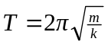
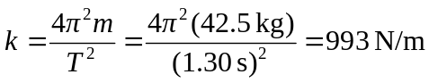
With person in chair:

